SAVITRIBAI PHULE PUNE UNIVERSITY

A PRELIMINARY PROJECT REPORT ON

Multiple disease detector system Using Machine Learning & Deep Learning

SUBMITTED TOWARDS THE
PARTIAL FULFILLMENT OF THE REQUIREMENTS OF

BACHELOR OF ENGINEERING (Computer Engineering)

BY
Student Name: Amar Bhade Exam No:BCOD68 Student Name: Pankaj Phulera Exam No:BCOD33 Student Name: Divyaamshu Verma Exam No:BCOD26 Student Name: Vijay Aglawe Exam No:BCOD27

Under The Guidance of MR. Rupesh Mahajan



DEPARTMENT OF COMPUTER ENGINEERING DR. D. Y. PATIL INSTITUTE OF TECHNOLOGY SAVITRIBAI PHULE PUNE UNIVERSITY



CERTIFICATE

This is to certify that the Project “ Multiple disease detector using Machine learning and deep learning Techniques” .
Submitted by

Student Name: Amar Bhade Exam No:BCOD68 Student Name: Divyaamshu Verma Exam No: BCOD26 Student Name: Pankaj Phulera Exam No: BCOD33 Student Name: Vijay Aglawe Exam No: BCOD27

is a bonafide work carried out by Students under the supervision of Prof. Guide Rupesh Mahajan and it is submitted towards the partial fulfillment of the requirement of Bachelor of Engineering (Computer Engineering) Project.

Prof. Rupesh Mahajan Prof.(Dr. S.V. Chobe) Internal Guide H.O.D
Dept. of Computer Engg. Dept. of Computer Engg..

(DR.Lalit kumar wadhwa) Principal,
Dr.D.Y. Patil Institute of Technology Pune -18

Department of Computer Engineering

ABSTRACT

Machine learning and Artificial Intelligence are playing a huge role in today’s world. From self-driving cars to medical fields, we can find them everywhere. The medical industry generates a huge amount of patient data which can be processed in a lot of ways. So, with the help of machine learning, we have created a Prediction System that can detect more than one disease at a time. Many of the existing systems can predict only one disease at a time and that too with lower accuracy. Lower accuracy can seriously put a patient’s health in danger. We have considered three diseases for now that are kidney ,thyroid and cancer in the future, many more diseases can be added. The user has to enter various parameters of the disease and the system would display the output whether he/she has the disease or not. This project can help a lot of people as one can monitor the persons’ condition and take the necessary precautions thus increasing the life expectancy.
Keywords : Kidney, Covid, Cancer, XgBoost, Random forest,CNN,Thyroid

DPU, Department of Computer Engineering 2022 I

Acknowledgments

Please Write here Acknowledgment.Example given as It gives us great pleasure in presenting the preliminary project report on ‘’.Multiple disease detector system Using Machine Learning & Deep Learning ”.

I would like to take this opportunity to thank my internal guide Prof. rupesh mahajan for giving me all the help and guidance I needed. I am really grateful to them for their kind support. Their valuable suggestions were very helpful.

I am also grateful to Prof. HOD santosh chobe, Head of Computer Engineering De- partment, College Name for his indispensable support, suggestions.

Amar Bhade
Pankaj Phulera
Divyaamshu Verma
Vijay Aglawe (B.E. Computer Engg.)

DPU, Department of Computer Engineering 2022 II

INDEX

INTRODUCTION 1
1.1 Overview . . . . . . . . . . . . . . . . . . . . . . . . . . . . . . .
1.2 Motivation . . . . . . . . . . . . . . . . . . . . . . . . . . . . . . .
1.3 Problem Definition . . . . . . . . . . . . . . . . . . . . . . . . . .
1.4 Project Objectives . . . . . . . . . . . . . . . . . . . . . . . . . . .

Literature Survey 4
2.1 Study Of Research Paper . . . . . . . . . . . . . . . . . . . . . . .

Software Requirements Specification 7
Introduction
Project Scope Methodology……………………………………………………………
………………… Functional Requirements
System feature
EXTERNAL INTERFACE REQUIREMENT
User Interface Hardware Interfaces:
Software Interfaces
NON FUNCTIONAL REQUIREMENT
Performance Requirements Safety Requirement Software Quality Attributes
System Requirements.................................................................................. .
Database Requirements .................................................................. .
Software Requirements

WFFGG

Hardware Requirements
- System Analysis 15
system Architecture
Data Flow Diagram…………………………………………………………………
…..
- Other Specification 17
Advantages Limitations
- Conclusion 19
Conclusion Future Scope
- References 21

DPU, Department of Computer Engineering 2022

WFFGG

CHAPTER 1 INTRODUCTION

1

OVERVIEW

A lot of analysis over existing systems in the health care industry considered only one disease at a time. For example, one system is used to analysediabetes, another is used to analyse diabetes retinopathy, and another system is used to predict heart disease. Maximum systems focus on a particular disease. When an organization wants to analyse their patient’s health reports then they have to deploy many models. The approach in the existing system is useful to analyse only particular diseases. In multiple diseases prediction system a user can analyse more than one disease on a single website. The user doesn’t need to traverse different places in order to predict whether he/she has a particular disease or not. In multiple diseases prediction system, the user needs to select the name of the particular disease, enter its parameters and just click on submit. The corresponding machine learning model will be invoked and it would predict the output and display it on the screen. 1.2 Problem system.

MOTIVATION

  - We have prepared a large set of COVID-19 chest X-ray image dataset, kidney thyroid containing 768 images with their corresponding binary labels.The rich collection of the Chest X-ray images with a clear sign of the disease are used for further classification.
  - A three-step hybrid model involving deep learning, extensive feature selection and ML classifiers is designed for detection of COVID-19 using chest X-ray images.
  - The deep models pre-trained on the Chest X-ray Pneumonia dataset act as feature extractors, followed by the feature selection using PCC and variance thresholding. The selected features are classified using ML-based predictive classifiers which showed high sensitivity to the optimally selected features.
  - We also provided the correlation analysis on features, depicting feature pair count per correlation coefficient and corresponding heat map for selected features.
  - Extensive experimental analysis with comparative study using mRMR, Relief-f and QPFS techniques on the proposed model is performed using five- fold stratified cross-validation.

PROBLEM DEFINITION

Many of the existing machine learning models for health care analysis are concentrating on one disease per analysis. For example first is for liver analysis, one for cancer analysis, one for lung diseases like that. If a user wants to predict more than one disease, he/she has to go through different sites. There is no common system where one analysis can perform more than one disease prediction. Some of the models have lower accuracy which can seriously affect patients’ health. When an organization wants to analyse their patient’s health reports, they have to deploy many models which in turn increases the cost as well as time Some of the existing systems consider very few parameters which can yield false results.
2
2 DPU, Department of Computer Engineering 2022

PROJECT OBJECTIVES

The aim of this study is to develop and test a reliable diagnostic tool, using deep learning technology to detect COVID-19 ,cancer disease, kidney chronic disease and cancer to features from chest X-rays, and medical data . This tool would accelerate the diagnosis and referral of patients, improving clinical outcomes.

Releasing the deep learning model as open source would facilitate the use of the tool both now and in any future pandemics, where a similar algorithm could be used.Also we used the Xgboost
,Random Forest ,CNN layers.

This particular application also has the potential to be scaled up and used for more generalised high-impact applications in biomedical imaging.

3

- DPU, Department of Computer Engineering 2022

CHAPTER 2 LITERATURE SURVEY

4

  - STUDY OF RESEARCH PAPER
A research paper is a document of a scientific article that contains relevant expertise, including substantive observations, and also references to a specific subject of philosophy and technique. Use-secondary references are reviewed in literature and no current or initial experimental work is published.

REVIEW: 1.

According to the paper focuses about as covid 19 and cancer is one of the dangerous diseases in the world , it can cause many varieties of disorders which includes breast cancer etc .In this paper they have used machine learning techniques to find out kindey disease as it is easy and flexible to forecast whether the patient has illness or not . Their aim of this analysis was to invent a system that can help the patient to detect the cancer disease of the patient with accurate results. Here they used mainly 4 main algorithms random forest , xgboost and cnn algorithms and compared their accuracy which is 85%,77%, 77.3% respectively . They also used cnn algorithm after the training process to see the reactions of the network which states whether the disease is classified properly or not . Here they compared the precision recall and F1 score support ad accuracy of all the models[1] . 2. The main aim of the paper is ,as heart plays an important role in living organisms. So the diagnosis and prediction of kidney related disease should be perfect and correct because it is very crucial which can cause death cases related to kidney .So Machine learning and Artificial Intelligence supports in predicting any kind of natural events .So in this paper they calculate accuracy of machine learning for predicting heart disease using k-nearest neighbor ,random forest, linear regression and cnn by using UCI repositor dataset for training and testing . They also compared the algorithm and their accuracy cnn 83 %,random forest 79%,Linear regression 78%,k-nearest neighbour 87%[2]. 3. The system defines that cancer diseases is causing high number of deaths in India and is also considered as a life threating disease in the world. As it is difficult to detect the cancer disease at early stage .So using automated program using machine learning algorithms we can detect the cancer disease accurately .They used and compared cnn,xgboost and Random forest algorithm and measures precision, accuracy and recall metrics for quantitative measurement. The accuracy are 95%,87%,92% respectively. 2.Animesh Hazra et al. [1] proposed Heart diseases when irritated winding path out of hand. Heart diseases are convoluted and remove loads of lives each year. When the early side effects of heart diseases are overlooked, the patient may wind up with
5

uncommon outcomes in a short length of time. Stationary way of life and over the top worry in this day and age has exacerbated the circumstance. On the off chance that the diseases are distinguished early, at that point it very well may be monitored. Be that as it may, it is constantly prudent to practice every day and dispose of undesirable propensities at the soonest.

3. “Multi Disease Prediction Using Data Mining Techniques” (2017).In this study two different data mining classification techniques was used for the prediction of various diseases and their performance was compared in order to evaluate the best classifier. An important challenge in data mining and machinelearning areas is to build precise and computationally efficient classifiers for Medical applications.

4. “Prediction of Heart Disease Using Machine Learning Algorithms” (2018). In this paper, two supervised data mining algorithm was applied on the dataset to predict the possibilities of having heart disease of a patient, were analyzed with classification model namely Naïve Bayes Classifier and Decision tree classification. The Decision tree model has predicted the heart disease patient with an accuracy level of 91% and Naïve Bayes classifier has predicted heart disease patient with an accuracy level of 87%.

5. “Analysis of Heart Disease Prediction Using Datamining Techniques”(2017) Heart disease is one of the leading causes of deaths worldwide and the early prediction of heart disease is very important.In this study prove that the proposed new algorithm achieves a highest accuracy compare with another algorithm.

6. “Review of Medical Disease Symptoms Prediction Using Data Mining Technique”(2017) In this paper evaluate the performance of medical disease prediction based on data mining technique. The classifier classified the medical diagnosis of disease data such as cancer, liver problem, and heart disease and so on. SVM method better classified data in compression of conventional cluster ensemble technique.

6

5

6

CHAPTER 3

SOFTWARE REQUIREMENTS SPECIFICATION

7

Project Scope

The study employs five deep learning techniques to classify CXR images with COVID-19 or non-COVID-19 labels with and without a late fusion technique. Also predict kidney cancer and thyroid.

Methodology

Knn Algorithm:

The working of the K-NN algorithm is as followed:

Step-1: Start to select the K value for example k=5 Step-2: Then we will find the Euclidean distance
between the points.

(𝑥2 − 𝑥1)² + (𝑦2 − 𝑦1)²
√
Euclidean Distance -

Step-3: Then we will calculate the Euclidean distance of the nearest neighbour.
Step-4: Then count the number of the data points in each category .For example found three values
for Category A and two values for category B.
Step-5: Then assign the new point to the category having maximum number of neighbours. For example Category A has highest number of neighbour so we will assign the new data point
to category A.
Step-6: So finally our Knn model is ready.

Random Forest Algorithm:
Random Forest working is possible in two phases ,first is to create the random forest by merging N decision tree, and second is making prediction for each tree created in the first phase.
The working of the random forest is as follows:
Step-1: Firstly it will select random K data points from the training set.
Step-2: After selecting k data points then building the decision trees associated with the selected data points (Subsets).
Step-3: Then choosing the number N for decision trees that you want to build.
Step-4:Repeating step 1 and 2 .
Step-5: Finding the predictions of each decision tree, and assigning the new data points to the category that wins the majority votes.

8

XGBoost Algorithm:

The working of XGBoost algorithm are as follows: Step 1: Firstly creating a single leaf tree.
Step 2: Then for the first tree, we have to compute the average of target variable as prediction and then calculating the residuals using the desired loss function and then for subsequent trees the residuals come from prediction that was there in previous tree.
Step 3: Calculating the similarity score using formula:
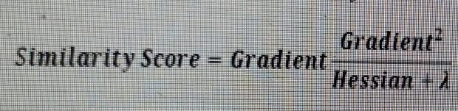
where, Hessian is equal to number of residuals; Gradient2 = squared sum of residuals; λ is a regularization hyperparameter.
Step 4: Applying similarity score we select the appropriate node. The higher the similarity score more the homogeneity. Step 5: Applying similarity score we calculate Information gain. Information gain help to find the difference between old similarity and new similarity and tells how much homogeneity is achieved by splitting the node at a given point.
Step 6:Creating the tree of desired length using the above method pruning and regularization can be done by playing with the regularization hyperparameter.
Step 7: Then we can predict the residual values using the Decision Tree you constructed.
Step 8: The new set of residuals is calculated as: where ρ is the learning rate.
Step 9:Then go back to step 1 and repeat the process for all.

FUNCTIONAL REQUIREMENTS

System feature

  - Database: to store user input or uploaded x-ray image and input data.

  - User: User upload X-ray image, Medical Data in system.

  - System: In system, Deep learning Model detect the person is suffering from diseases.
9

EXTERNAL INTERFACE REQUIREMENT

User Interface

To detect the person is suffered from Covid-19, Cancer, Kidney and Thyroid.

Hardware Interfaces:

- RAM : 8 GB
As we are using Machine Learning Algorithm and Various High Level Li- braries Laptop.
- RAM minimum required is 8 GB.

- Hard Disk : 500 GB

- Processor : Intel i5 Processor

10

Software Interfaces

- Programming Language : python

- Operating System : Windows 10

NON FUNCTIONAL REQUIREMENT

Performance Requirements
The system allows the patient to predict the disease

The user adds the input for the particular disease and based on the trained model of the user input the output will be displayed .

Non Functional Requirement

- The website will provide range of the values during the prediction of the disease.The website should be reliable and consistent.

Architecture Design

In the figure no 4.1 we have experimented on three diseases that is Kidney, Covid and Cancer as these are correlated to each other. The first step is to the dataset for Kidney, Covid and Cancer we have imported the UCI dataset, PIMA dataset and Indian liver dataset respectively. Once we have imported the dataset then visualization of each inputed data takes place. After visualization pre-processing of data takes place where we check for outliers, missing values and also scale the dataset then on the updated dataset we split the data into training and testing .Next is on the training dataset we had applied knn, xgboost and random forest algorithm and applied knowledge on the classified algorithm using testing dataset. After applying knowledge we will choose the algorithm with the best accuracy for each of the disease .Then we build a pickle file for all the disease and then integrated the pickle file with the flask framework for the output of the model on the webpage.

11

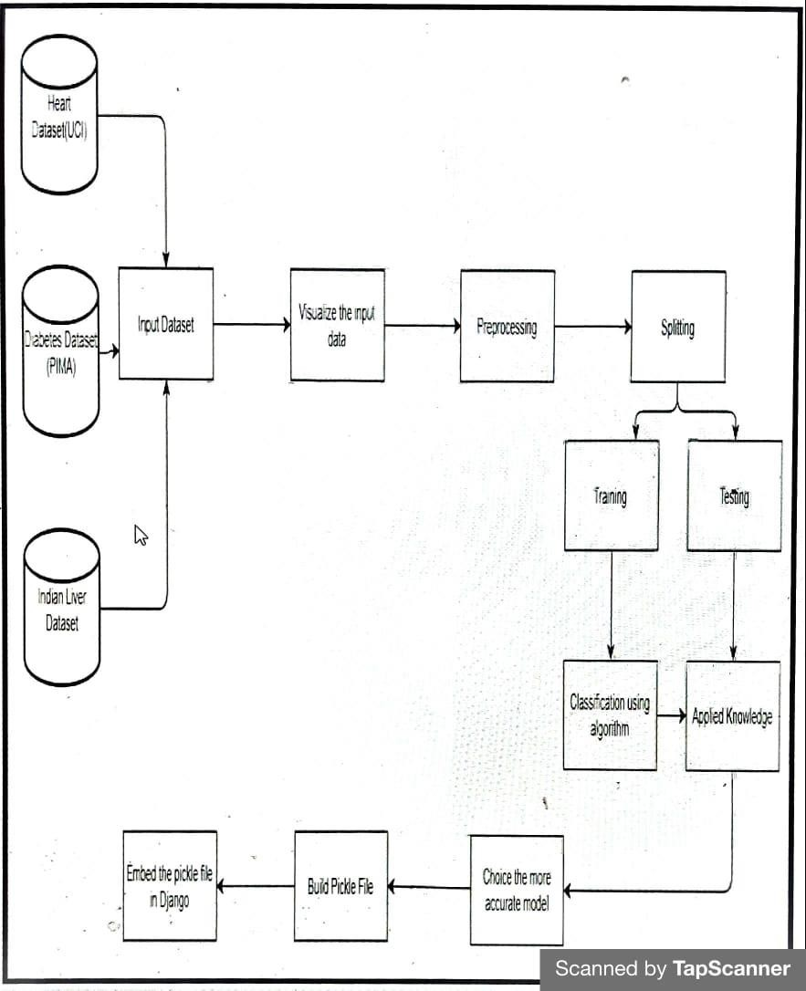
Figure No 3.1: Block Diagram

Safety Requirement

The application is designed in modules where errors can be detected and fixed easily. This makes it easier to install and update new functionality if required.

12

Software Quality Attributes

  - Our software has many quality attribute that are given below:

  - Adaptability: This software is adaptable by all users

  - Availability: This software is freely available to all users. The availability ofthe software is easy for everyone.

  - Maintainability: After the deployment of the project if any error occurs then it can be easily maintained by the software developer.

  - Reliability: The performance of the software is better which will increase the reliability of the Software.

  - User Friendliness: Since, the software is a GUI application; the output gen- erated is much user friendly in its behavior.

  - Integrity: Integrity refers to the extent to which access to software or data by unauthorized persons can be controlled.

  - Security: Users are authenticated using many security phases so reliable se- curity is provided.

  - Test ability: The software will be tested considering all the aspects.

13

SYSTEM REQUIREMENTS

Database Requirements

Structured Query Language (SQL) is a standardized programming language that is used to manage relational databases and perform various operations on the data in them. Initially created in the 1970s, SQL is regularly used not only by database ad- ministrators, but also by developers writing data integration scripts and data analysts looking to set up and run analytical queries. The term SQL is pronounced ess-kew- ell or sequel. SQL is used for the following: modifying database table and index structures; adding, updating and deleting rows of data; and retrieving subsets of information from within relational database management sys- tems (RDBMSes) – this information can be used for transaction processing, analyt-ics applications and other applications that require communicating with a relational database. SQL queries and other operations take the form of commands written as statements and are aggregated into programs that enable users to add, modify or re-trieve data from database tables.

14

CHAPTER 4 SYSTEM ANALYSIS

15

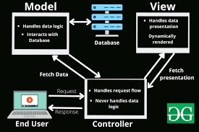
As shown in the above figure, the raw data from the original dataset is passed onto the first phase i.e. Data pre-processing. In Data pre-processing this raw data is then cleaned of all redundancies, missing values etc. The new clean data is fit for training different algorithmic models on it.
Figure 4.1: system Architecture

SYSTEM ARCHITECTURE:

Data Flow Diagram in Data Flow Diagram, we Show that flow of data in our system in DFD0 we show that base DFD in which rectangle present input as well as output and circle show our system, In DFD1 we show actual input and actual output of system input of our system is text or image and output is rumor detected likewise in DFD 2 we present operation of user as well as admin.

Figure 4.2: Data Flow diagram

16

Chapter 5
Other Specification

17

ADVANTAGES

    - Works with good accuracy as compared to other models.

    - User friendly.

    - Cost effective.

    - Less time consumption.

LIMITATIONS

- Chest X-Ray and Medical data is required.

- It’s not 100% accurate. Accuracy can be increased using another algorithm.

- Less secure.

18

CHAPTER 6

CONCLUSION

19

CONCLUSION

The main objective of this project was to create a system that would predict more than one disease and do so with high accuracy. Because of this project the user doesn’t need to traverse different websites which saves time as well. Diseases if predicted early can increase your life expectancy as well as save you from financial troubles. For this purpose, we have used various machine learning algorithms like Random Forest, XGBoost, and K nearest neighbor (KNN) ,CNN Architecture to achieve maximum accuracy.

FUTURE SCOPE

- In the future we can add more diseases in the existing API.
- We can try to improve the accuracy of prediction in order to decrease the mortality rate.
- Try to make the system user-friendly and provide a chatbot for normal queries

20

DPU, Department of Computer Engineering 2022

CHAPTER 7 REFERENCES

21
- Priyanka Sonar, Prof. K. JayaMalini,” Cancer PREDICTION USING DIFFERENT MACHINE LEARNING APPROACHES”, 2019 IEEE ,3rd International Conference on Computing Methodologies and Communication (ICCMC)

- Archana Singh ,Rakesh Kumar, “Kidney Disease Prediction Using MachinLearning Algorithms”, 2020 IEEE, International Conference on Electrical and Electronics Engineering (ICE3).

- A.Sivasangari, Baddigam Jaya Krishna Reddy,Annamareddy Kiran, P.Ajitha,” Diagnosis of Liver Disease using Machine Learning Models” 2020 Fourth International Conference on I-SMAC (IoT in Social, Mobile, Analytics and Cloud) (I-SMAC)

- A. M. Ismael and A. Şengür, “Deep learning approaches for COVID-19 detection based on chest X- ray images,” Expert Systems with Applications, vol. 164, Article ID 114054, 2021.

- E. E.-D. Hemdan, M. A. Shouman, and M. E. J. A. P. A. Karar, Covidx-Net: A Framework of Deep Learning Classifiers to Diagnose Covid-19 in X-Ray Images, MedRxiv, Cold Spring, NY, USA, 2020.

- K. Sahinbas and F. O. Catak, “Transfer learning-based convolutional neural network for COVID-19 detection with X-ray images,” in Data Science for COVID-19, Elsevier, Amsterdam, Netherland, 2021.

- A. K. Das, “Automatic COVID-19 detection from X-ray images using ensemble learning with convolutional neural network,” Pattern Analysis and Applications, vol. 24, pp. 1–14, 2021.

- A. K. Jaiswal, P. Tiwari, V. K. Rathi, J. Qian, H. M. Pandey, and V. H. C. J. M. Albuquerque, Covidpen: A Novel Covid-19 Detection Model Using Chest X-Rays and Ct Scans, MedRxiv, Cold Spring, NY, USA, 2020.

22

DPU, Department of Computer Engineering 2022

